### **Communities**

**Question 1**: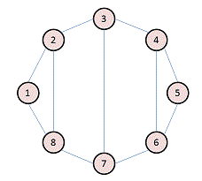

For the following graph:

Write the adjacency matrix A, the degree matrix D, and the Laplacian matrix L. For each, find the sum of all entries and the number of nonzero entries.

Ans.

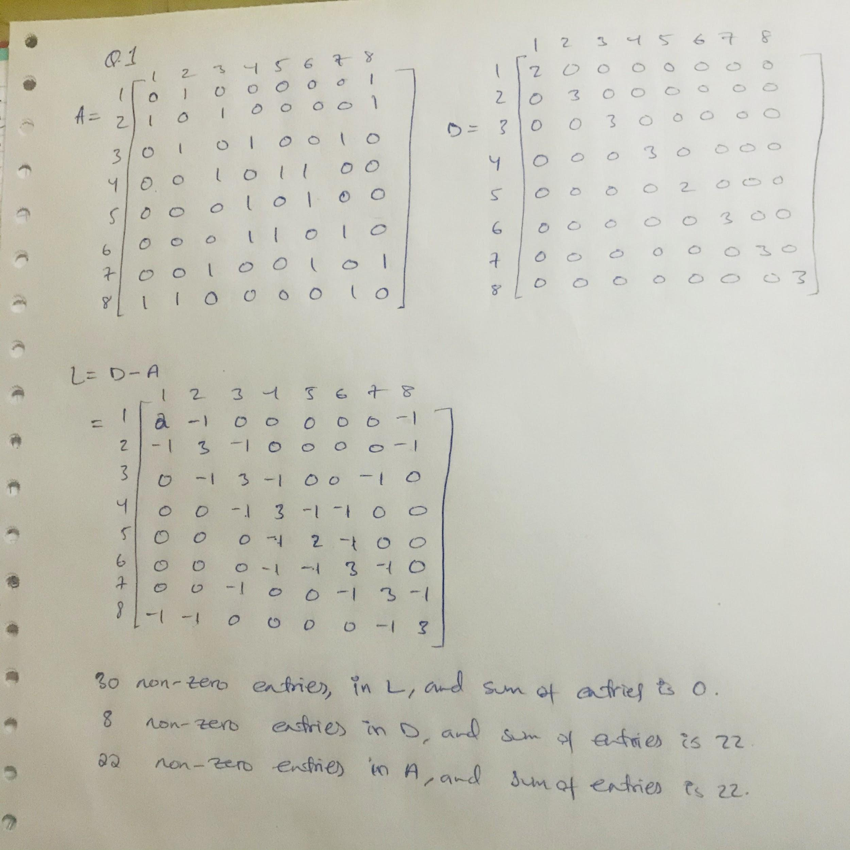**Question 2**:

Consider the following undirected graph (i.e., edges may be considered bidirectional):

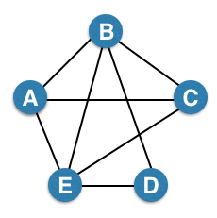

Run the "trawling" algorithm for finding dense communities on this graph and find all complete bipartite subgraphs of types K3,2 and K2,2. Note: In the case of K2,2, we consider {{W, X}, {Y, Z}} and {{Y, Z}, {W, X}} to be identical.

Ans.

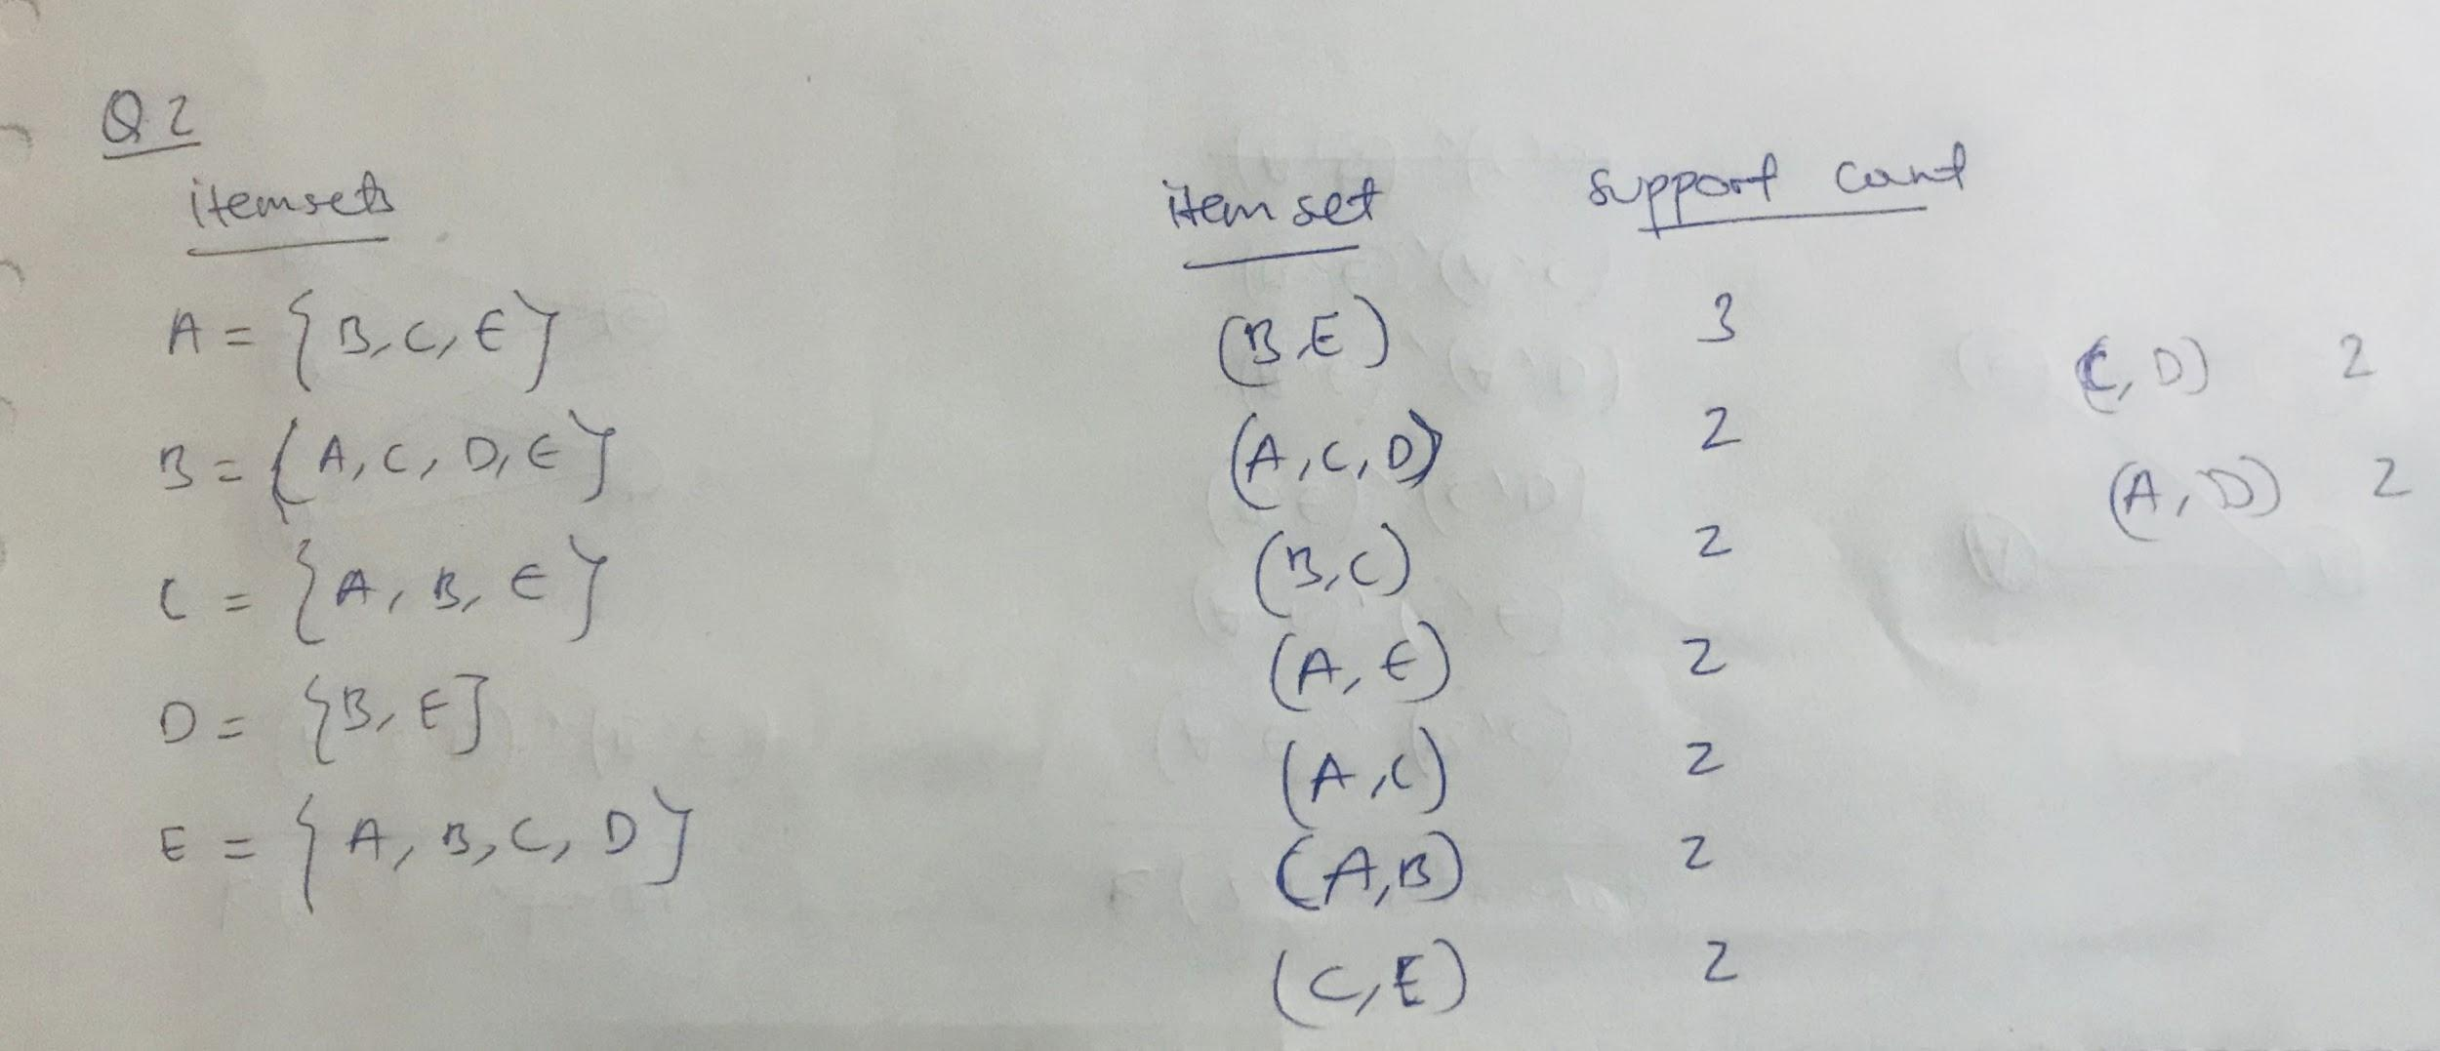

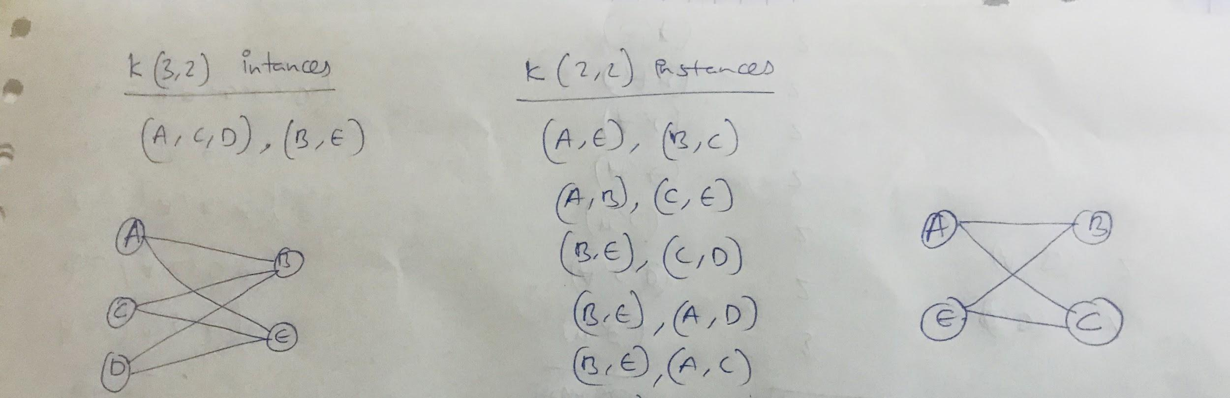

**Question 3**:

We fit AGM to the network on the left, and found the parameters on the right: 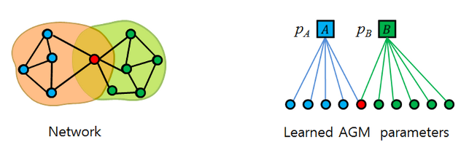

Find the optimal values for pA and pB.

Ans. pB = 0.6